

Constitution of the Icarus arts society



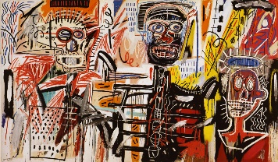

The Icarus arts society

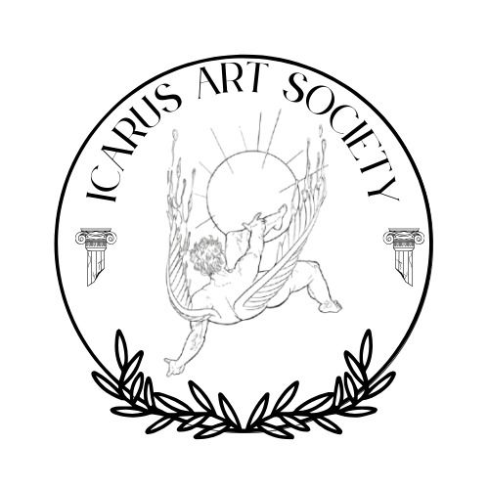

***To be Icarus...*** “So much to do, so little done.”  
Prisoners of King Minos. Prisoners of society. We, Icarus and I are trapped along with those that raise us. For him, that’s Daedalus, his father. For me, that’s my ambition. They create what we need to escape the chains society feels we need placed on our psyche. Our fathers and ambitions, make for us wings, with which we feel the tinge of stardom as we soar leagues overhead. Wanting more, our fathers, ambitions, tell us to pace ourselves, to not go too far in too short a time. To not fly too fast to the point we’re out of sight. To not fly too high up in the sky, lest our wings of ambition, dreams and drive decide to burst in flames and let the flame within us die out. Going up in flames, Icarus comes crashing down like a shooting star into the glistening sea of regrets and realizations. Gulping on, “art doesn’t pay”, swallowing, “you can never make it”, suffocating on, “you’re not good enough”, We, Icarus and I begin to realize it’s not that deep. For like phoenixes from the ashes, we can be raised again, and we will, for unlike Icarus, as artists we are given the chance to try again, this time with the understanding, “tot facienda parum factum.” So much to do, so little done.

**Article 1: Name and Ideology**

1. Name

The official name of the organization shall be The Icarus Arts Society, hereinafter referred to as "the Society."

1. Ideology

The Society operates on three core ideologies: The Eyes, The Hand, and The Heart.

The Eyes  
The Society aims to showcase the presence and significance of creatives at NUST, ensuring that their talents and contributions are seen and recognized within the institution.

The Hand  
The Society strives to create opportunities for creatives by establishing internal and external platforms where students can express themselves, explore their artistic potential, and share their work.

The Heart  
The Society is dedicated to building a thriving community of like-minded individuals who share ideas, support each other, and enrich the lives of students through creative expression, fostering a sense of belonging and offering a constructive form of entertainment.

**Article 2: Purpose and Objectives**

* 1. Purpose

The primary purpose of The Icarus Arts Society is to foster artistic growth, provide opportunities for creatives, and create a dynamic and inclusive artistic community at NUST.

* 1. Objectives

The objectives of the Society include, but are not limited to:

* + 1. Developing skills, promoting teamwork, building networks, and participating in community development projects.
    2. Cultivating various artistic skills and providing mentorship and guidance.
    3. Organizing events and platforms where students can showcase their talents.
    4. Establishing a strong network of creatives that supports all forms of artistic expression, regardless of scale or popularity.
    5. Educating and informing students on fundamental aspects of art and creativity.

**Article 3: Venue**

3.1 Primary Location

The Icarus Arts Society shall operate within the Namibia University of Science and Technology (NUST) in Windhoek, Namibia, or at any alternative location agreed upon by the executive members of the Society.

**Article 4: Governance and Structure**

4.1 Executive Committee

The Society shall be governed by an executive committee consisting of the following positions:

1. President
2. Vice President
3. Secretary
4. Treasurer
5. Events Coordinator
6. Public Relations Officer
7. Publicity and Media Officer

4.2 Responsibilities

**President**

Oversees all Society activities,   
Represents the Society, and  
Ensures smooth operation.

**Vice President**

Assists the President and   
Takes on leadership in their absence.  
Is part of the disciplinary committee which deals with matters of suspension and expulsion of from members from the society along with impeachment.

**Secretary**

Maintains records, minutes, and   
Correspondence.  
Is part of the disciplinary committee which deals with matters of suspension and expulsion of from members from the society along with impeachment.

**Treasurer**

Manages finances,   
Budgeting, and   
Fundraising efforts.

**Events Coordinator**

Plans and   
organizes events and programs.

**Public Relations Officer**

Manages communication and   
Promotional efforts.

**Publicity and Media Officer**

Oversees social media,   
Graphic design, and   
Visual representation of the Society.

**Honorary Member**

Is part of the disciplinary committee which deals with matters of suspension and expulsion of from members from the society along with impeachment.

**Article 5: Membership**

5.1 Eligibility

Membership is open to any individual registered as a student at NUST.

5.2 Honorary Membership

Relevant stakeholders, including but not limited to:

1. faculty members
2. alumni
3. individuals outside of NUST who contribute to the Society's mission

may be granted honorary membership at the discretion of the executive committee.

**Article 6: Meetings and Decision-Making**

6.1 General Meetings

General meetings shall be held at least once per semester.

Members will be notified at least two weeks in advance.

6.2 Executive Meetings

Executive committee meetings shall be held monthly or as needed.

Decisions shall be made by majority vote. In the event disputes arise, any of the four executive positions/five individuals(4.1.1 – 4.1.4) shall have the ability to retake a vote where the only voters are those within the aforementioned positions. A majority 3 of 5 vote shall hold/stand.

6.3 Quorum

A quorum for general meetings shall consist of at least 50% of active members.

A quorum for executive meetings shall consist of at least 4 executive members.

**Article 7: Finances**

7.1 Sources of Funding

The Society shall secure funds through:

1. Membership fees
2. Donations and sponsorships
3. Fundraising events

7.2 Financial Management

The Treasurer shall maintain accurate financial records.

All expenditures shall be approved by the executive committee.

An annual financial report shall be presented to members.

**Article 8: Code of Conduct**

8.1 General Guidelines

The Icarus Arts Society expects all members to adhere to a standard of professionalism, respect, and ethical behaviour. The following rules shall apply:

* Censorship applies to all forms of art showcased under the Society’s name. Works must align with ethical and institutional standards.
* The consumption of dangerous substances before, during, or after representing the Society at any event is strictly prohibited.  
  Art should not be used to promote hate speech, discrimination, or personal political and ideological agendas.
* All members must respect fellow creatives, fostering an inclusive and supportive environment.
* Any form of harassment, misconduct, or disruptive behaviour will result in disciplinary action, including potential suspension or expulsion from the Society.
* Public representations of the Society, including performances, exhibitions, and digital content, must maintain a professional standard that upholds the Society's values and reputation.

**Article 9: Amendments**

9.1 Proposal and Approval

Amendments to this constitution may be proposed by any active member.

Proposed amendments must be submitted in writing to the executive committee.

Amendments require a two-thirds majority vote of present members in a general meeting.

Certain amendments may carry a degree of urgency that may require for immediate action and if the timeline is far enough from the general meeting, these special amendments shall be the responsibility of the executive four(not including the whole executive council) to deliberate and vote on.  
Far enough meaning 12 working days.

**Article 10: Impeachment/Expulsion/Suspension**

10.1 Requirements/Prerequisites

For such an article to be invoked, one must have valid reasons(i) as to why they wish to remove a specific member of the executive committee/a general member and a proposed replacement.

1. Valid reasons include but are not limited to:
2. Multiple breeches of the rules set under the constitution of The Icarus Arts Society Article 8, clause 8.1.
3. Any violations of the Constitution of the State or the governing body under which the representative is of jurisdiction.
4. Any violations of the Constitution of the NUST, Namibian University of Science and Technology.

10.2 Voting/Verdict procedures

For the matter to reach a verdict, the accused must be voted against 2 out of 3 by the relevant body(i)

1. The relevant body includes:
2. The Vice President (or the Acting Vice President in his/her absence)
3. The Secretary (or the acting Secretary in his/her absence)
4. Any honorary member available for such a hearing.